Physical activity as an effect modificator of lifestyle factors on small vessel deisease burden
Abstract
Background and aims Physical activity (PA) may reduce the development of small vessel disease (SVD). The effect of physical activity and more classical vascular risk factors such as hypertension and diabetes in the development of SVD is debated, however. We aim to investigate the effect modification of physical activity on traditional vascular risk factors and the burden of small vessel disease among acute ischemic stroke patients.
Methods We have pooled patients from two clinical trials on acute ischemic stroke treatment. The main outcome is an ordinal scale score of quantified MR biomarkers of small vessel disease (SVD) burden based on visually assessed acute stroke scans (T2* or SWI and FLAIR sequences). Biomarkers includes microbleeds, old lacunar infarcts, superficial siderosis, white matter hyperintensities and atrophy. Covariates includes age, sex, pre-stroke physical activity, diabetes, hypertension, atrial fibrillation and previous cardiovascular diseases. Pre-stroke PA was assessed with a questionnaire on inclusion within a few days after stroke onset. Data will be analyzed using bivariate and multivariate linear regression analysis.
Results We expect to include a total of around 1000 adult patients admitted to the comprehensive stroke centre at Aarhus University Hospital between 2013-2022. Preliminary results will be presented at ESOC 2024.
Conclusions Physical activity may be an important factor in modifying the risk of SVD development in stroke patients.
_{Source: Article Notebook}

Introduction
THe correlation between physical activity, small vessel disease and classical risk factors is very much debated and not fully understood.(Moniruzzaman et al. 2020; Torres et al. 2019; Landman et al. 2021)
In this abstract, we present the preliminary results from our pooled SVD study, also presented at ESOC 2024.

Methods
This study is a cross-sectional study, based on a pooled dataset from two different randomised, clinical trials on patients with acute stroke.

Results
Please refer to Figure 1 for an overview of subjects included for analysis.
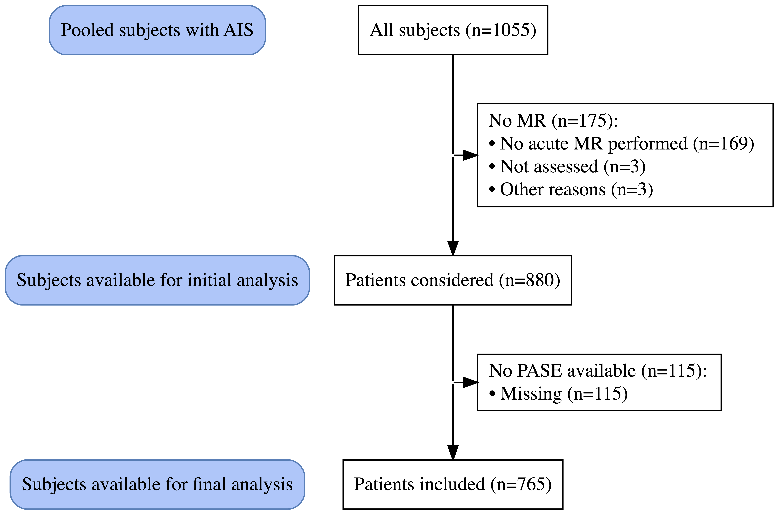
Figure 1: Flowchart of subject included for analysis
_{Source: Article Notebook}
Baseline characteristics are included with the Table 1.
Table 1: Baseline values SVD burden score
Characteristic | Overall, N = 765 | Female, N = 280 | Male, N = 485
SVD score
0 | 302 (39%) | 105 (38%) | 197 (41%)
1 | 216 (28%) | 75 (27%) | 141 (29%)
2 | 142 (19%) | 61 (22%) | 81 (17%)
3 | 71 (9.3%) | 29 (10%) | 42 (8.7%)
4 | 34 (4.4%) | 10 (3.6%) | 24 (4.9%)
Age | 71 (62, 79) | 75 (64, 80) | 70 (61, 77)
Admission NIHSS | 4.0 (2.0, 7.0) | 4.0 (2.0, 8.0) | 3.0 (2.0, 7.0)
Treated with tPA | 460 (60%) | 159 (57%) | 301 (62%)
Treated with EVT | 100 (13%) | 30 (11%) | 70 (14%)
Pre-stroke PASE score | 108 (60, 161) | 89 (55, 136) | 116 (71, 175)
Living alone | 203 (27%) | 120 (43%) | 83 (17%)

_{Source: Article Notebook}
Scoring reliability between raters has been compared using different metrics, to show different nuances to the performance, see Table 2. The main performance measure is the intraclass correlation ceofficient.
Table 2: Inter rater reliability testing
Variable | Agreement | Krippendorffs_Alpha | Fleiss_Kappa | Brennan_Predigers_Kappa | IntraclCorrCoef
microbleed | 0.90 | 0.65 | 0.65 | 0.80 | 0.65
lacunes | 0.83 | 0.56 | 0.56 | 0.66 | 0.56
wmh | 0.88 | 0.72 | 0.72 | 0.75 | 0.72
atrophy | 0.81 | 0.54 | 0.54 | 0.63 | 0.54
score | 0.62 | 0.46 | 0.46 | 0.52 | 0.75
_{Source: Article Notebook}
Below is the initial evaluation of possible PA effect modification on classical risk factors, Table 3. These results indicates no effect modification as odds ratios are largely unchanged, when PA is introduced in the model (on the right). This may not be the optimal method for this kind of evaluation, though.
Table 3: Multivariate, ordianal, logistic regression analysis without and with PASE score included
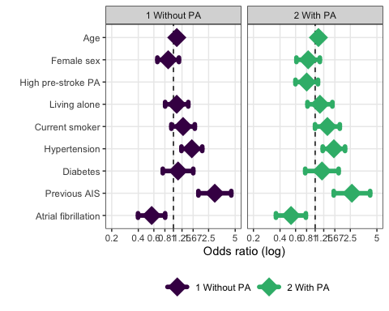
_{Source: Article Notebook}
Based on the preliminary SVD-scores, SVD score distribution stratified by PA quartile is presented in Figure 2.
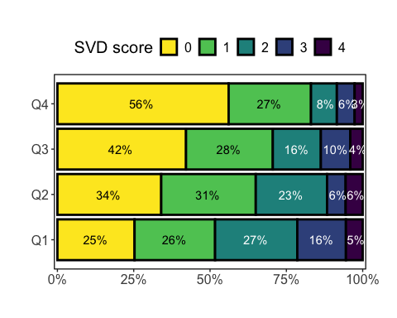
Figure 2
_{Source: Article Notebook}

Discussion
The numbers and figures presented here are very much preliminary and should only be used for discussion and inspiration. Also, if you have any interest in collaboration, please reach out!
Landman, Thijs Rj, Dick Hj Thijssen, Anil M. Tuladhar, and Frank-Erik de Leeuw. 2021. “Relation between physical activity and cerebral small vessel disease: A nine-year prospective cohort study.” International Journal of Stroke: Official Journal of the International Stroke Society 16 (8): 962–71. https://doi.org/10.1177/1747493020984090.
Moniruzzaman, Mohammad, Aya Kadota, Hiroyoshi Segawa, Keiko Kondo, Sayuki Torii, Naoko Miyagawa, Akira Fujiyoshi, et al. 2020. “Relationship Between Step Counts and Cerebral Small Vessel Disease in Japanese Men.” Stroke 51 (12): 3584–91. https://doi.org/10.1161/STROKEAHA.120.030141.
Torres, Elisa R., Siobhan M. Hoscheidt, Barbara B. Bendlin, Vincent A. Magnotta, Gabriel D. Lancaster, Roger L. Brown, and Sergio Paradiso. 2019. “Lifetime Physical Activity and White Matter Hyperintensities in Cognitively-Intact Adults.” Nursing Research 68 (3): 210–17. https://doi.org/10.1097/NNR.0000000000000341.

